
National University Of Modern Languages, Islamabad

User Experience Design (UXD)

Lab Task 5

Task: Yale School Of Art (Website)

Name: Zulqarnain Hassan
Class: 6A Afternoon
Roll no: SP-21379
Assigned Date: 06 March 2025
Deadline: 10 March 2025
Figma Design Link: https://www.figma.com/design/5jCtVxiOwlpKD2tyHX7IhI/university_websit?node-id=123-248&t=f3srckdY2TemFlNv-1

Marks Obtained
Remarks

Issues:

Design Screenshots:
Page 1: Home screen
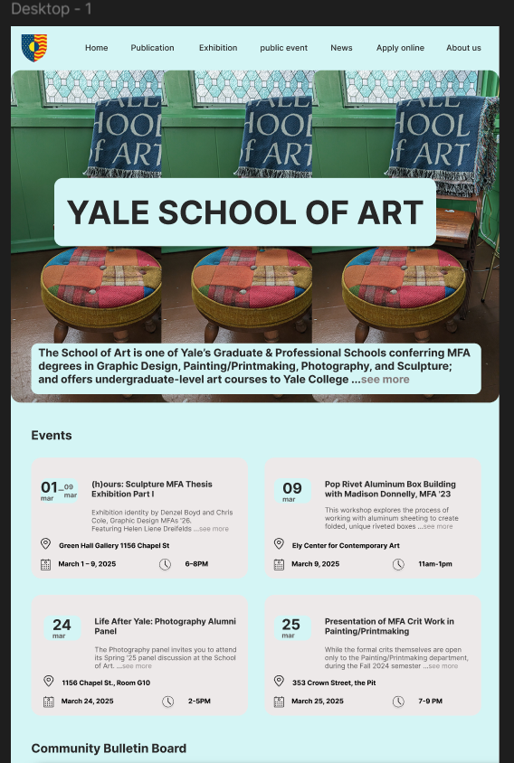
Page 1: Home screen continue
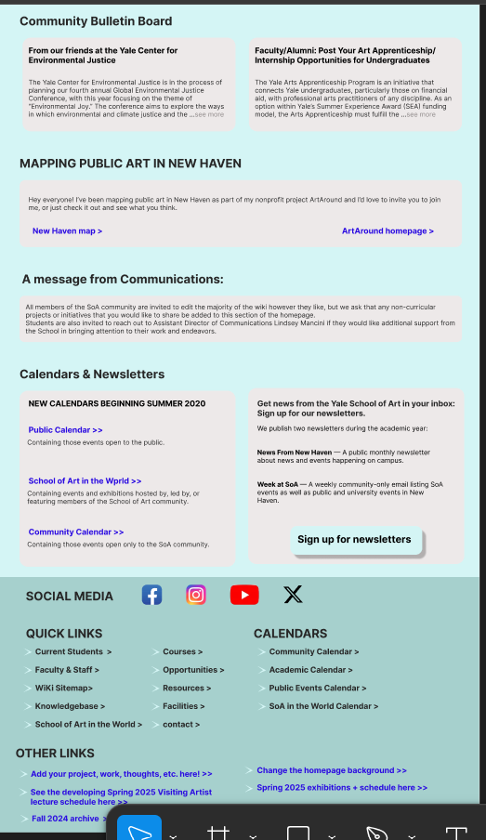
Page 2: Publications
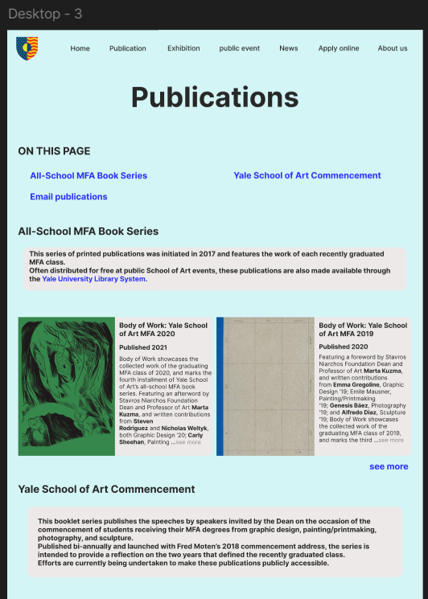
Page 2: Publications continue

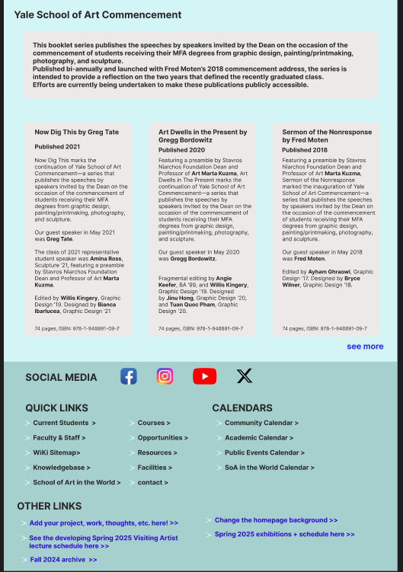
Page 3: Public Events
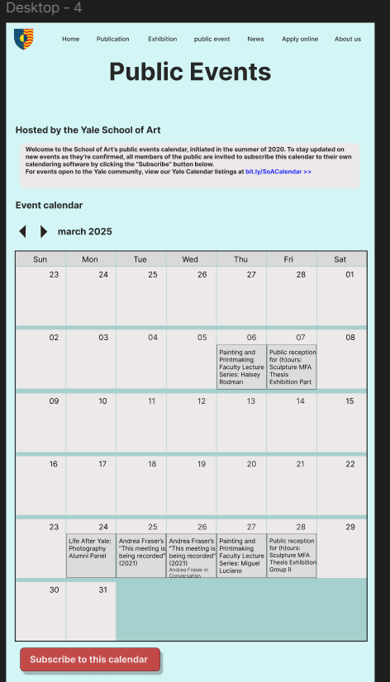

Page 4: Apply online
